**PIZAA SALES SQL TS**

1. KPI’s
2. Total Revenue :

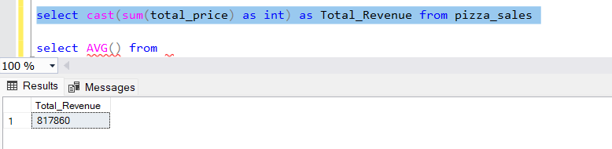

1. Average Order Value:

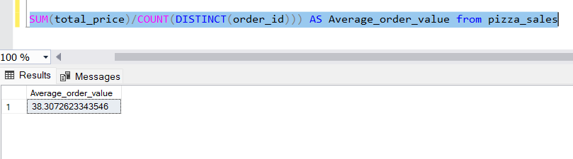

1. Total Pizza Sold

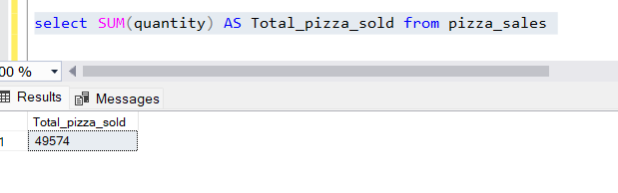

1. Total Orders

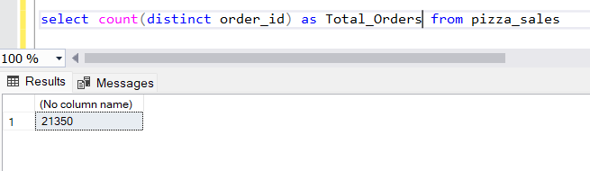

1. Average pizzas Per Order

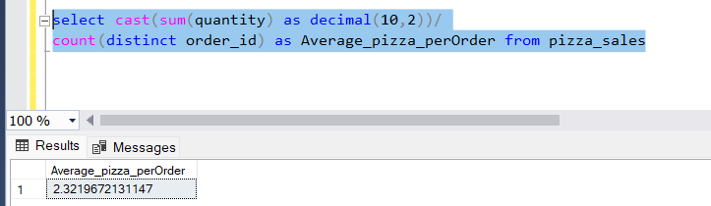

1. Daily Trend for Order

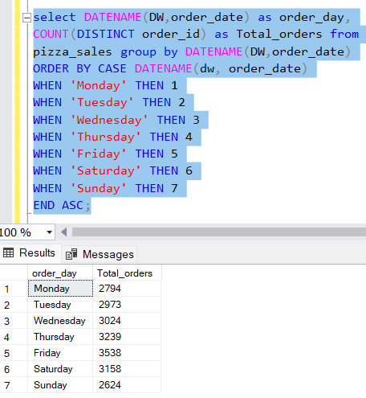

1. Monthly Trend For Order

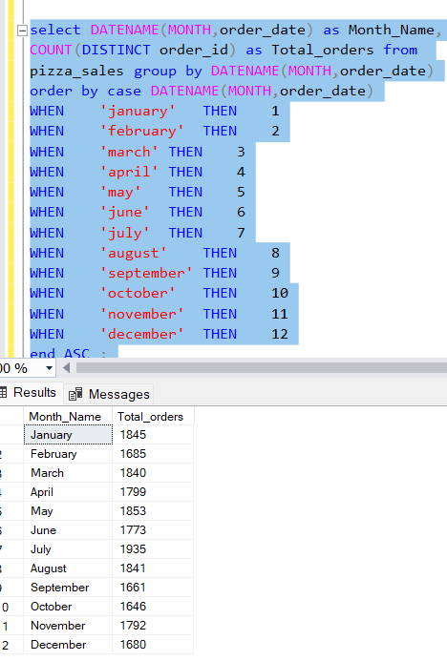

1. Percentage of sales by pizza category

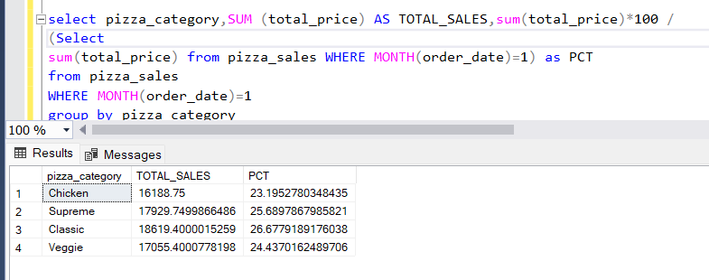

1. Total pizzas sold by pizza category

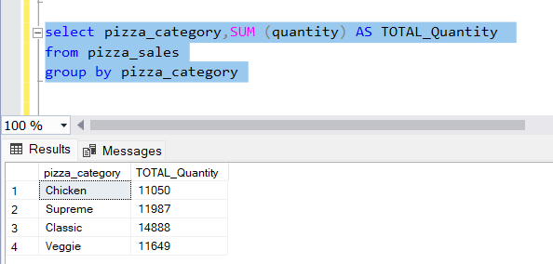

1. Top 5 Best Sellers By Revenue , Total Quantity and Total Orders

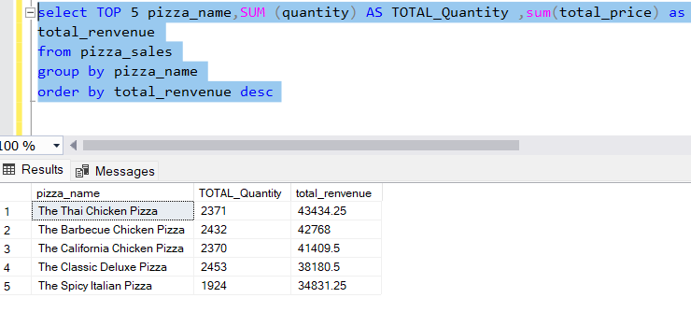

1. Bottom 5 sellers

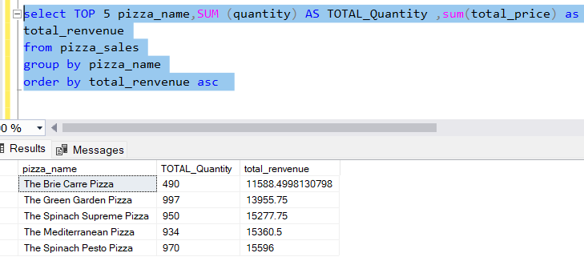

1. Top 5 and bottom 5 sellers

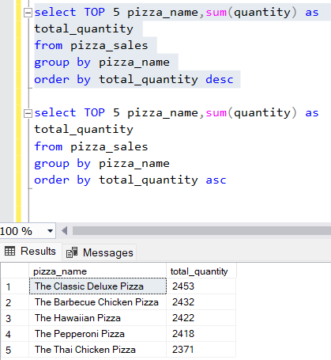

1. Top 5 and bottom 5 based on orders

